Project Title: Customer Category Classifier

Member 1: Ahnaf Jahin
ID: 24241206

Member 2: Wasima Fahmida Oishi
ID: 24241087

Section: 27
Course: CSE422
Semester: Summer 2025

Table of Contents

Introduction--------------------------------------------------- 3
Dataset Description------------------------------------------ 4-9
Dataset Preprocessing--------------------------------------- 9-10
Dataset Splitting---------------------------------------------- 10
Model Training & Testing---------------------------------- 10-14
Model Comparison & Evaluation------------------------ 14-18
Conclusion---------------------------------------------- 19

Introduction
The aim of this project is to develop a machine learning based classification model that predicts whether a customer has ever been married based on demographic and behavioral data. The primary objective was to develop and evaluate machine learning models for a binary classification task targeting the Ever_Married attribute. The problem is framed as a binary classification (Yes = 1, No = 0). The motivation behind this project is to understand customer segmentation which is crucial in targeted marketing, recommendation systems and customer profiling. Three models were implemented: K-Nearest Neighbors (KNN), Decision Tree and a Neural Network. We applied supervised learning models (KNN, Decision Tree, Neural Network) along with unsupervised clustering (K-Means) to evaluate model effectiveness and extract insights from the dataset.
Exploratory Data Analysis (EDA) revealed significant relationships between marital status and features like age, profession, and spending score. Model evaluation showed that the Neural Network and Decision Tree performed exceptionally well, achieving accuracies of 88.1% and 87%, respectively, and an AUC of 0.95. Additionally, an unsupervised K-Means clustering algorithm was applied, successfully identifying four distinct customer segments, which were visualized using Principal Component Analysis (PCA). These findings provide a robust framework for customer behavior prediction and strategic segmentation.

Dataset Description
The dataset contains 24,210 customer records with multiple demographic and lifestyle attributes. ● Target Variable: Ever_Married (Yes/No → Binary Classification)
● Problem Type: Classification (Binary)
This is a binary classification problem because the target variable, Ever_Married, has only two possible outcomes (Yes = 1, No = 0). The goal is to predict a categorical label rather than estimate a continuous numeric value. Classification models such as KNN, Decision Tree, and Neural Networks with a Sigmoid output are therefore appropriate. Additionally, the evaluation metrics used are: Accuracy, Precision, Recall, F1-score, and ROC-AUC are all designed for classification tasks, further confirming that the problem is not regression but classification.
● Dataset: 24,210
● Features: Both categorical (Gender, Profession, Spending_Score) and numerical (Age, Work_Experience, Family_Size).
● Encoding: Categorical features cannot be used directly in ML models. Therefore, One-Hot Encoding was applied. For example:
- Gender → {Male, Female} → encoded as binary 0/1
- Spending_Score → {Low, Average, High} → expanded into dummy variables
● Correlation Heatmap:
Correlation analysis revealed moderate correlations between Age and Ever_Married, as older individuals were more likely to be married. Family_Size had a moderate correlation. Other features (Profession, Spending_Score) showed weak correlations individually, suggesting that a combination of features is required for strong predictive performance.
2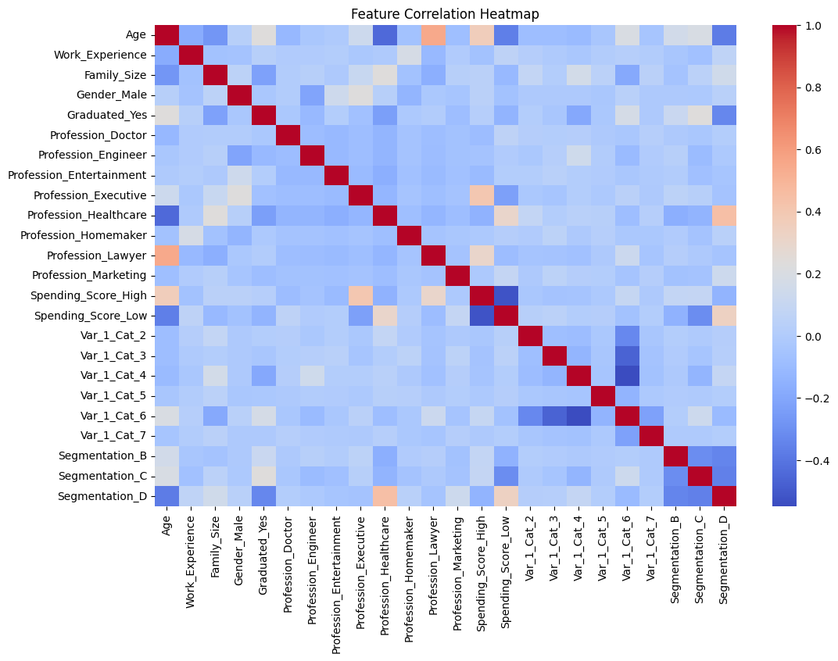
Figure: Correlation Heatmap
● Class Balance
The dataset was slightly imbalanced:
- Married (Yes): Majority (60%)
- Not Married (No): Minority (40%)
This imbalance was visualized through a class distribution bar chart.
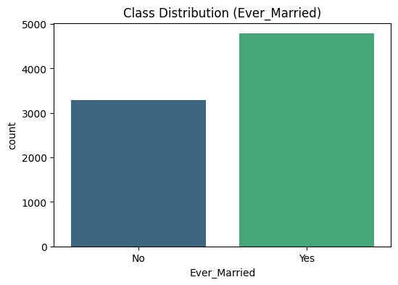
Exploratory Data Analysis (EDA)
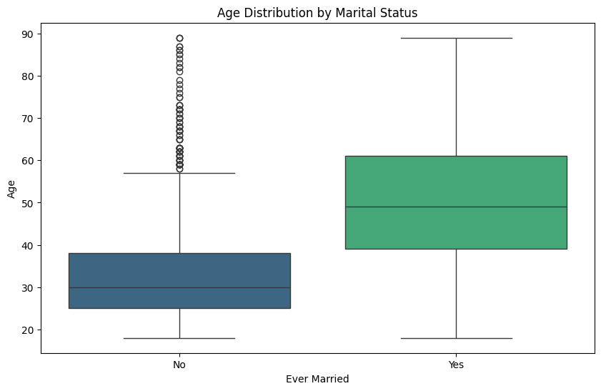
● Age vs. Marital Status: Married individuals tend to be older. (marriage likelihood increases with age.)
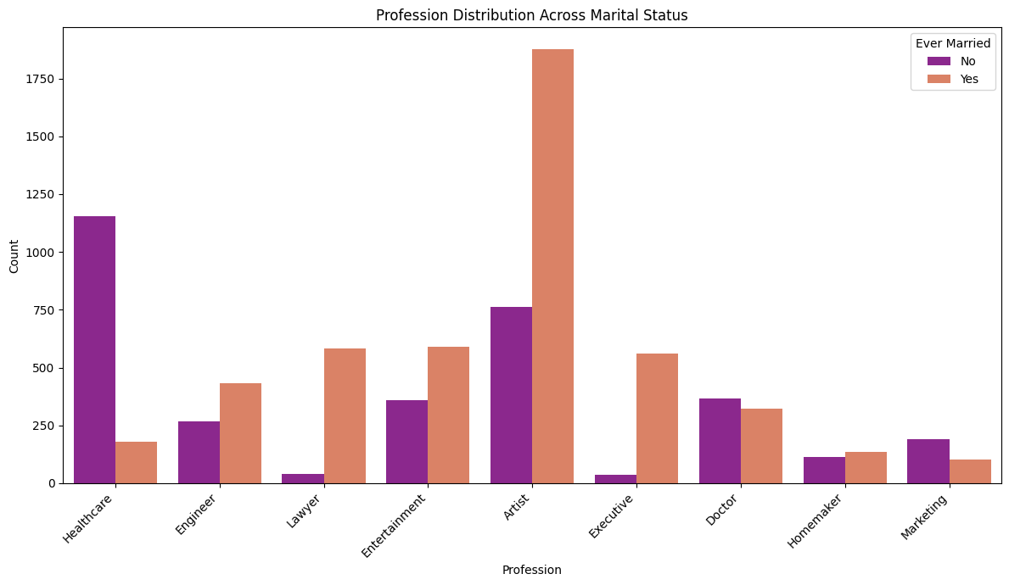
● Profession Distribution: Certain professions have a higher likelihood of being married. Customers in stable professions were more likely to be married.
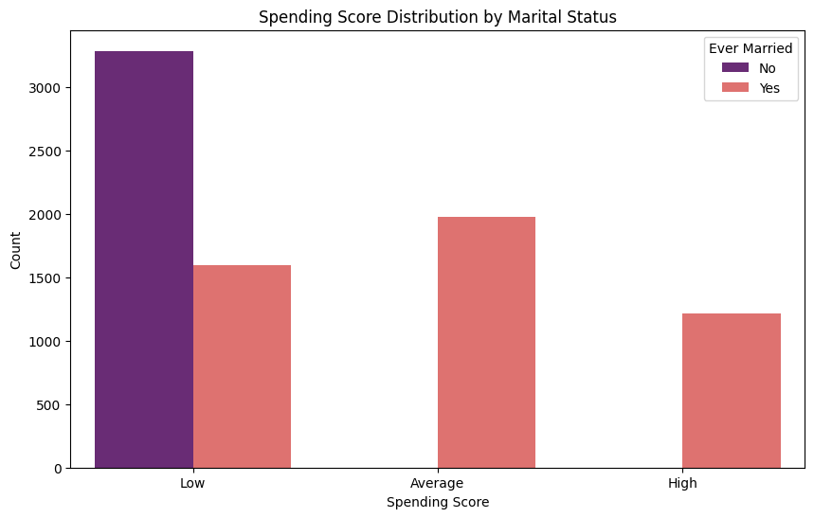
● Spending Score & Gender: Spending behavior shows differences across marital status and gender. Males showed slightly higher marriage rates than females.

● Histogram of Age: Younger customers dominate the dataset, but older ones show higher probability of being married (after age 28).
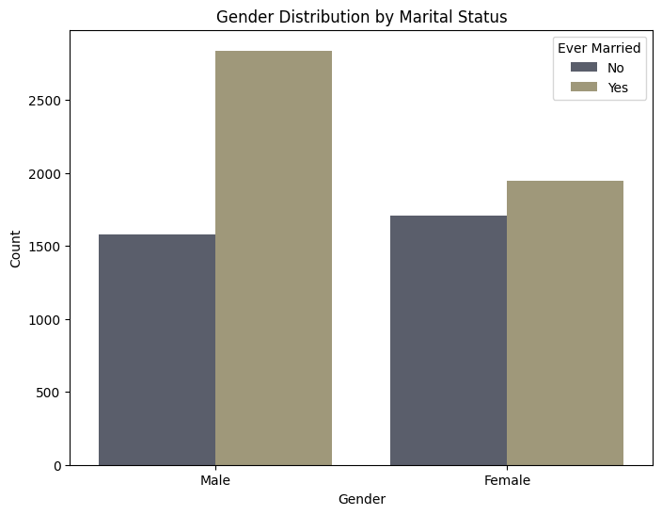
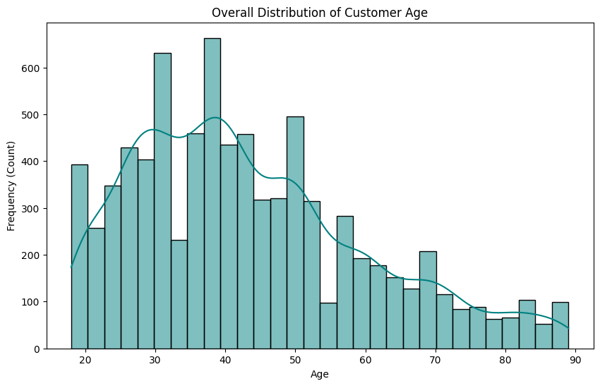
- The bars are divided into two parts: one for individuals who have never been married (labeled "No" in dark gray) and another for those who have ever been married (labeled "Yes" in a light tan color).
- The chart shows that the number of males who have ever been married is higher than the number of males who have never been married, with a similar trend for females, although the count of ever-married females appears slightly lower compared to ever-married males.

Dataset Preprocessing
Handling Missing Values:
Problem: The dataset had missing values in both numerical and categorical features, which could lead to biased training or data loss if ignored.
Solution:
- Numerical Features: Missing values were replaced with the mean (preserves dataset size).
- Categorical Features: Missing values were filled with the mode (most frequent value).
Encoding:
Problem: Categorical features (e.g., Gender, Profession, Spending_Score) could not be directly used in machine learning models because they are non-numeric
Solution: One-Hot Encoding was applied to categorical features to convert them into numerical vectors.
Feature Scaling:
Problem: Numerical features (Age, Family_Size, Work_Experience) were measured on different scales, which could mislead models are: especially KNN, which depends on Euclidean distance.
Solution: StandardScaler was used to normalize numerical features (Age, Family_Size, Work_Experience). Scaling is critical for KNN because it relies on Euclidean distance.

Dataset Splitting
The dataset was split into training and testing subsets using stratified sampling to maintain class balance:
● Training Set: 70% (16,947 records)
● Testing Set: 30% (7,263 records)

Model Training & Testing
We applied three supervised learning models and one unsupervised method.
- K-Nearest Neighbors (KNN):
● Parameters: k = 5, Euclidean distance
● Accuracy: 84%
● Observations: Worked reasonably well but was sensitive to high-dimensional data. Recall for “Married” was strong, but precision for “Not Married” was weaker.

- Decision Tree Classifier:
● Parameters: Max Depth = 6, Criterion = Gini Index
● Accuracy: 87%
● Observations: Balanced performance across classes. Easy to interpret (rules such as “If Age > 30 → likely Married”). Slightly overfitted compared to Neural Network but still strong.

- Neural Network :
- Architecture:
  - Input Layer: Number of neurons equal to the feature dimension.
  - Hidden Layer 1: 64 neurons, ReLU activation, Dropout = 0.3 (to reduce overfitting).
  - Hidden Layer 2: 32 neurons, ReLU activation.
  - Output Layer: 1 neuron, Sigmoid activation (for binary classification).

- Training Configuration:
  - Optimizer: Adam
  - Loss Function: Binary Crossentropy
  - Epochs: 50
  - Batch Size: 32

- Performance:
The neural network achieved an accuracy of 88.1% on the test set. It captured complex non-linear relationships in the dataset, outperforming KNN and Decision Tree. However, it was more computationally expensive and less interpretable compared to simpler models.

K-Means Clustering (Unsupervised):
- Optimal K (Number of Clusters): The Elbow Method was applied by plotting the Within-Cluster Sum of Squares (WCSS) against the number of clusters. The curve showed a noticeable “bend” (elbow) at K = 4, indicating that four clusters provide the best balance between model simplicity and explained variance.
- Visualization: Principal Component Analysis (PCA) reduced the high-dimensional feature space into 2D for visualization. The four clusters were clearly distinguishable in this reduced space.
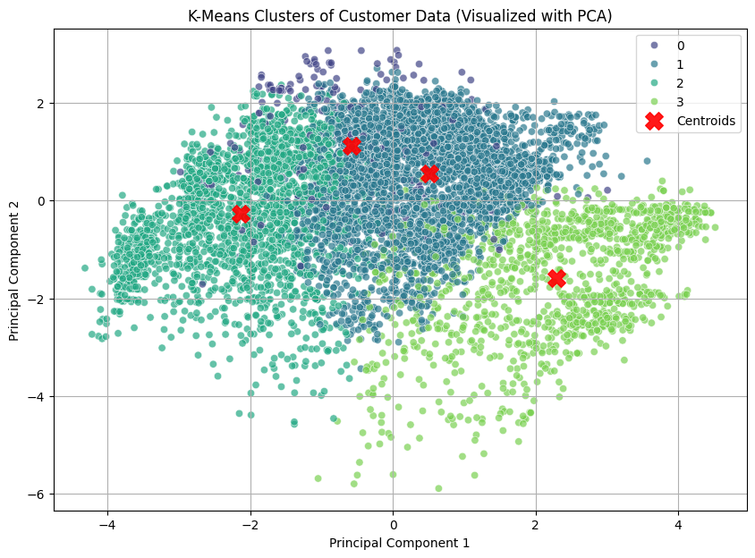

- Findings: The clustering revealed distinct customer segments. These segments showed partial alignment with marital status, but also reflected differences in spending score and profession, suggesting that customer behavior is influenced by multiple attributes rather than a single demographic factor.
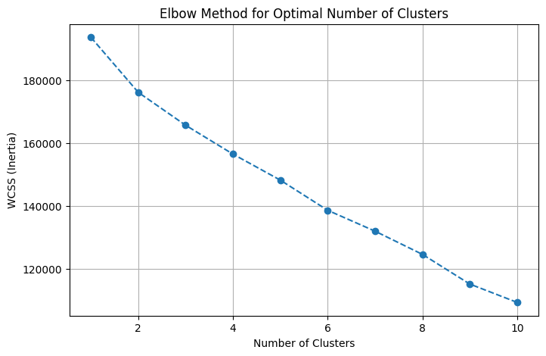

Model Comparison & Evaluation
The models were compared using multiple evaluation metrics:
- Accuracy Comparison:
● Neural Network = 88.1%
● Decision Tree = 87%
● KNN = 84%

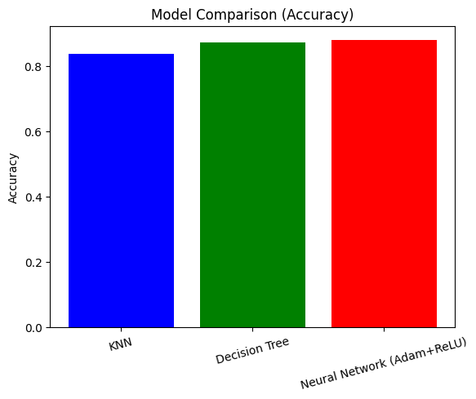

- Precision, Recall, F1-score:
● Neural Network performed best across all metrics.
● Decision Tree was competitive but less precise than NN.
● KNN had lower recall for “Not Married.”
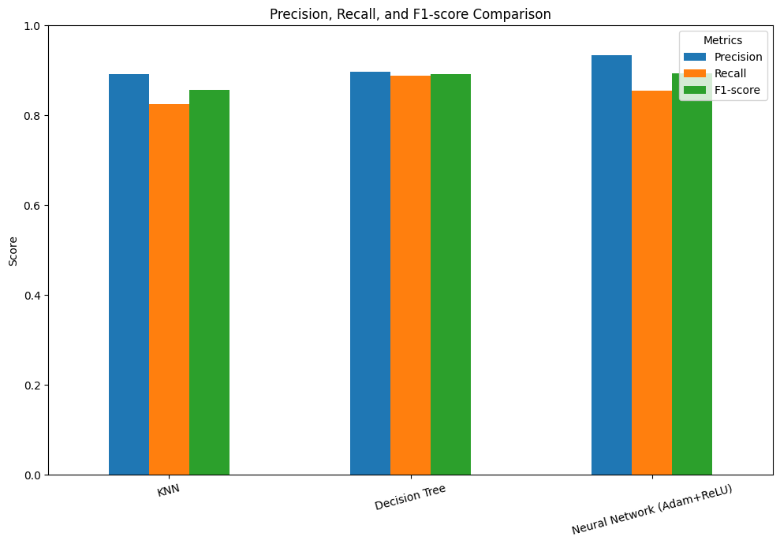
- Confusion Matrices:
● Neural Network: Smallest number of misclassifications.
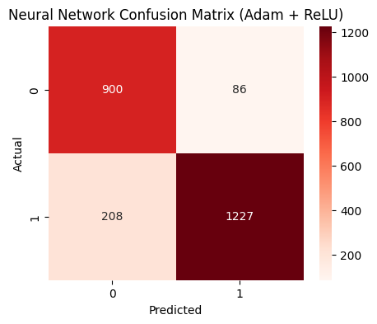
● Decision Tree: Balanced errors across classes.
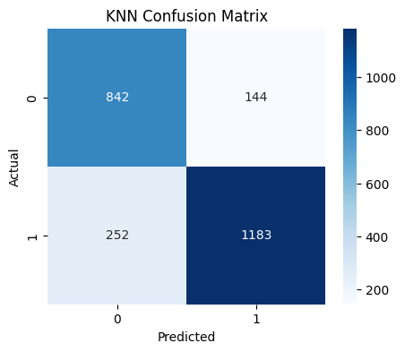
● KNN: More false negatives for “Not Married.”
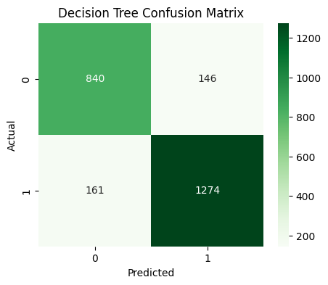

- ROC Curve & AUC:
● Neural Network achieved the highest AUC, showing superior ability to separate the two classes.
● Decision Tree performed moderately well.
● KNN showed the weakest curve but still acceptable.
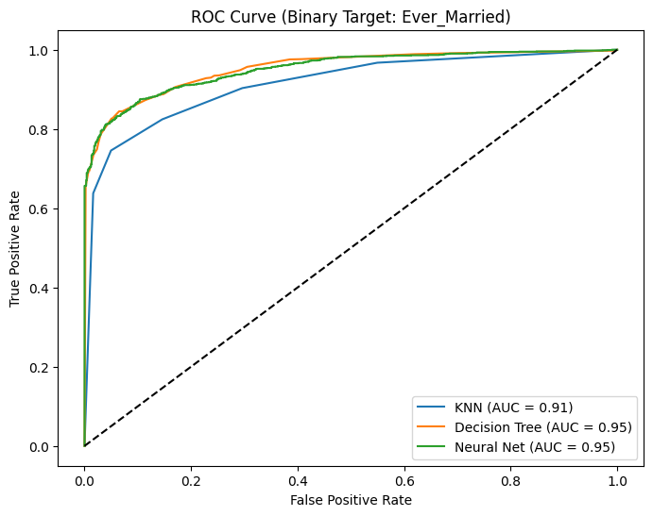

Conclusion
This project successfully demonstrated how supervised machine learning models can predict marital status using demographic and lifestyle data.
● Best Model: Neural Network with 88.1% accuracy.
● Interpretability vs. Performance:
Neural Network → best performance, less interpretable.
Decision Tree → good balance between accuracy and interpretability.
KNN → weaker but still useful for small-scale applications.
Challenges Faced:
1. Handling class imbalance.
2. Encoding high-cardinality categorical variables (Profession).
3. Trade-off between interpretability (Decision Tree) and performance (Neural Net). Future Improvements:
● Apply hyperparameter tuning for all models.
● Use ensemble methods (Random Forest, XGBoost) for stronger performance.
● Experiment with SMOTE to handle imbalance.
● Explore deep learning architectures for improved generalization.

